**Spring MVC Notes:**

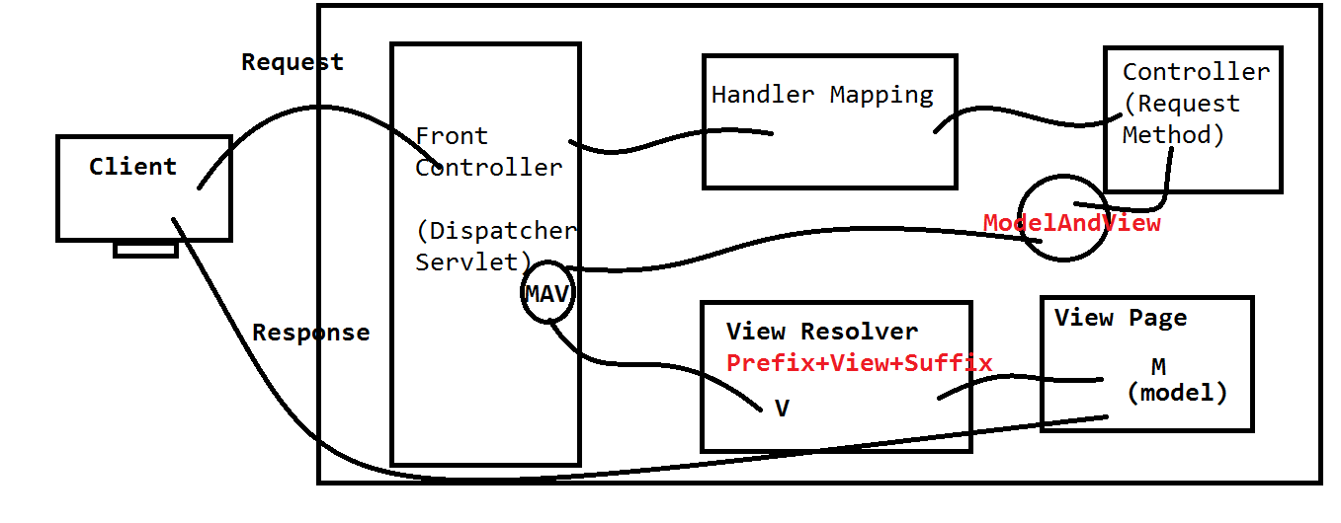

**>Change Perspective to JavaEE**

**> Get a server view.**

**(Window->Showview->server)**

**>select a server , browse Head/Installed Location.**

**>Finish**

**---------------------------------------------------**

**File>new>Dynamic Web Project.**

**Provide Project name>next>next> Check web.xml generation**

**>Finish**

**----------------------------**

**Sample Proram:**

**JARS:**

**Copy and paste all Spring-JARS in lib folder.**

**---------------------------------------**

**Step 1:**

**Configure DispatcherServlet in web.xml**

**step 2: creating spring config file:**

**name rule: [<servlet-name>]-servlet.xml**

**Location: /WEB-INF/ location.**

**Step 3: Configure A view Resolver Class. With prefix and**

**suffix.**

**Step 4: Controller**

**>Create a Java class.**

**>Use an annotation @Controller (Sterio type annot. )**

**>Enable annotations in config file**

**(use context schema for base pakage and annotation config)**

**>Writre a request method. (@RequestMapping("/url"))**

**ex: @RequestMapping("/home") -- GET type**

**@RequestMapping(value="/abcd",method=RequestMethod.POST)**

**> Return a ModelAndView Object.**

**ex:**

**return new ModelAndView("HomePage");**

**Step 5: VIEW : create a folder structure for prefix**

**(if not exist ex: /WEB-INF/jsps)**

**--------------------------------------**

**Note: RequestMethod is enum, which define named constans**

**for request methods like GET,POST,PUT,TRACE...etc**

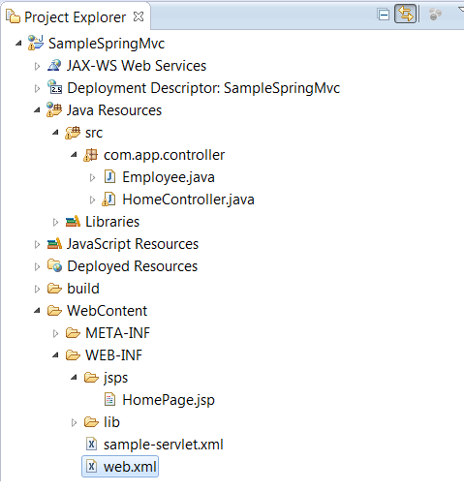

**Web.xml**

<?xml version=*"1.0"* encoding=*"UTF-8"*?>

<web-app xmlns:xsi=*"http://www.w3.org/2001/XMLSchema-instance"* xmlns=*"http://java.sun.com/xml/ns/javaee"* xsi:schemaLocation=*"http://java.sun.com/xml/ns/javaee http://java.sun.com/xml/ns/javaee/web-app_2_5.xsd"* id=*"WebApp_ID"* version=*"2.5"*>

<servlet>

<servlet-name>sample</servlet-name>

<servlet-class>org.springframework.web.servlet.DispatcherServlet</servlet-class>

</servlet>

<servlet-mapping>

<servlet-name>sample</servlet-name>

<url-pattern>/abcd/*</url-pattern>

</servlet-mapping>

</web-app>

Sample-servlet.xml

<?xml version=*"1.0"* encoding=*"UTF-8"*?>

<beans xmlns=*"http://www.springframework.org/schema/beans"*

xmlns:xsi=*"http://www.w3.org/2001/XMLSchema-instance"*

xmlns:p=*"http://www.springframework.org/schema/p"*

xmlns:c=*"http://www.springframework.org/schema/c"*

xmlns:context=*"http://www.springframework.org/schema/context"*

xsi:schemaLocation=*"http://www.springframework.org/schema/beans*

*http://www.springframework.org/schema/beans/spring-beans.xsd*

*http://www.springframework.org/schema/context*

*http://www.springframework.org/schema/context/spring-context.xsd*

*"*>

<context:annotation-config/>

<context:component-scan base-package=*"com.app.controller"*/>

<bean class=*"org.springframework.web.servlet.view.InternalResourceViewResolver"*>

<property name=*"prefix"*>

<value>/WEB-INF/jsps/</value>

</property>

<property name=*"suffix"*>

<value>.jsp</value>

</property>

</bean>

</beans>

HomeController.java

**package** com.app.controller;

**import** java.util.ArrayList;

**import** java.util.List;

**import** org.springframework.stereotype.Controller;

**import** org.springframework.web.bind.annotation.RequestMapping;

**import** org.springframework.web.bind.annotation.RequestMethod;

**import** org.springframework.web.servlet.ModelAndView;

@Controller

**public** **class** HomeController {

@RequestMapping("/home")

**public** ModelAndView showView(){

ModelAndView mav=new ModelAndView();

mav.setViewName("Home");

**return** **mav;**

}

@RequestMapping(value="/home",method=RequestMethod.*POST*)

**public** ModelAndView showView1(){

**return** **null**;

}

}

home.jsp

<h1>Welcome to Spring</h1>

URL:- http://localhost:8080/SampleSpringMVC/abcd/home